Lab 11 – Worksheet

Name: Ghazi Hussain, Sarosh Mehdi, Sualeh Abbas, Hamza Hassan | ID: Group 10 | Section: T2

Task a: vga_sync

Code: Design module vga_sync
Provide appropriately commented code for designed module, the code should contain meaningful variable naming.
*Add snippet or Copy paste the code written in the Editor window. Make sure the irrelevant area of the snip is cropped.
CODE FOR VGA_SYNC

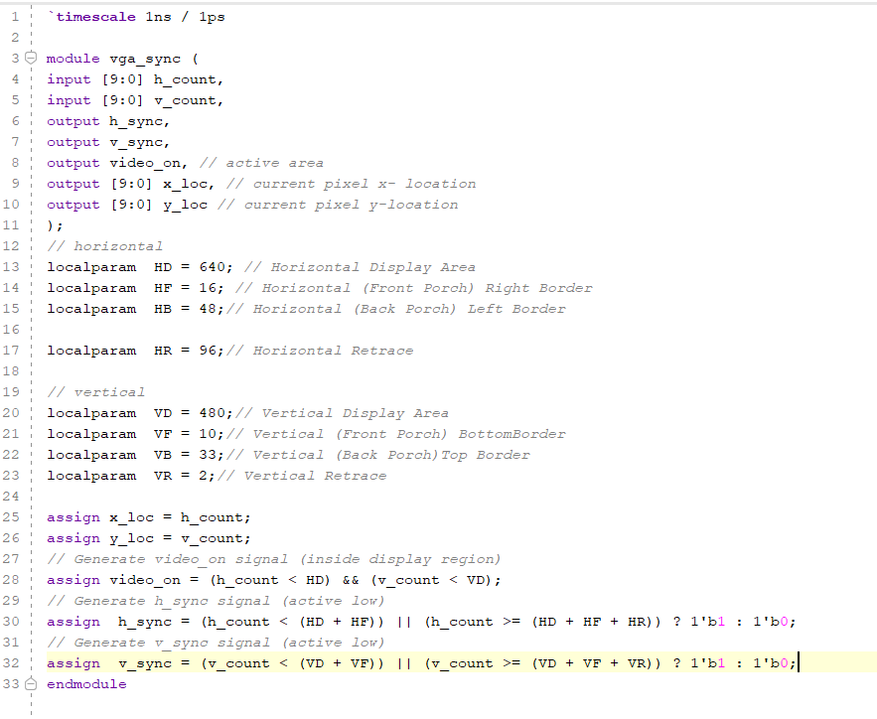

TESTBENCH

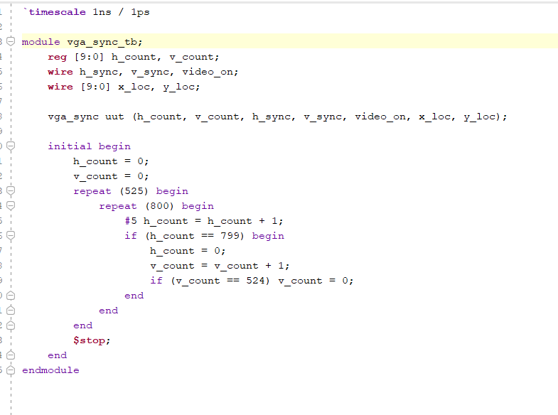

Results (Waveforms)
*Add snip of relevant signals’ waveforms. Make sure the irrelevant area of the snip is cropped.
make sure to scale properly for visibility of all case.
TEST CASE 1:-
The simulation is showing the very first line of the video frame (v_count = 0). The current pixel being displayed is the 506th pixel in the horizontal scan line (h_count = 506). Since video_on = 1, this pixel will be shown on the screen.Both h_sync and v_sync are high, meaning we're in the sync pulse phase — possibly at the end of a line and also during the vertical retrace.
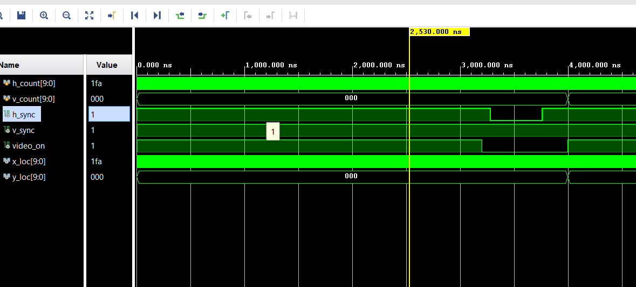

TEST CASE 2”:-
• This is the 320th pixel of the 20th line of the frame.The pixel is in the visible region (video_on = 1), so it’s part of what the user would see on a display.The horizontal sync (h_sync) and vertical sync (v_sync) are both high — which typically indicates the system is in a sync interval, but in this case, it's happening while video_on is still high. Transition to the next line (v_count = 014) is about to happen, as shown at the next major timestamp (~80,000 ns).
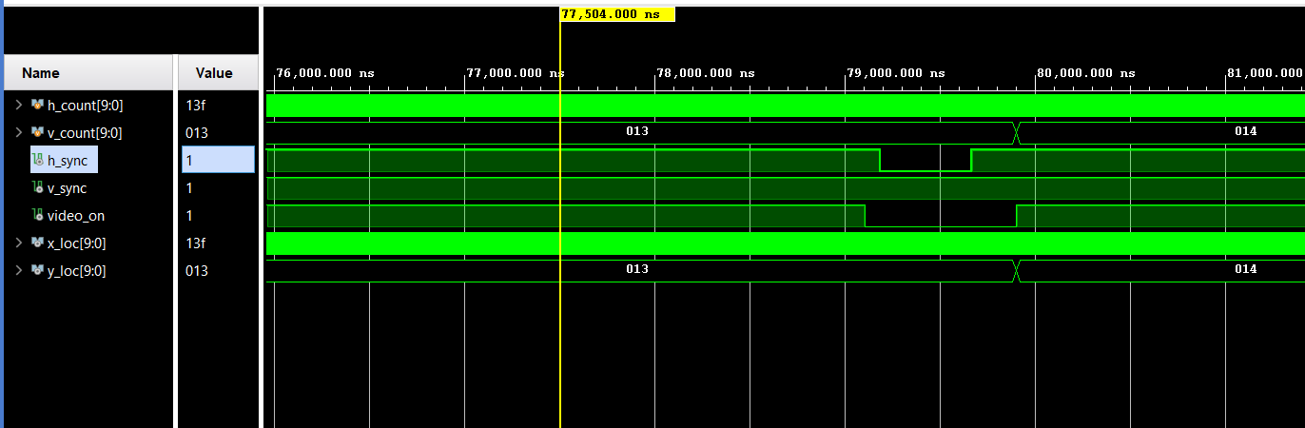

TEST CASE 3:-
• Pixel Location: You're at pixel (719, 23), which is typically near the end of a horizontal line (since horizontal counts usually wrap at 800 in 640x480 mode).video_on = 0:. h_sync = 0: No horizontal sync pulse at this moment — so this is inside the visible or front porch period.v_sync = 1; vertical sync pulse, which means this is during a frame refresh (not visible to screen). Even though x_loc and y_loc give pixel coordinates, no image is shown since video_on is 0
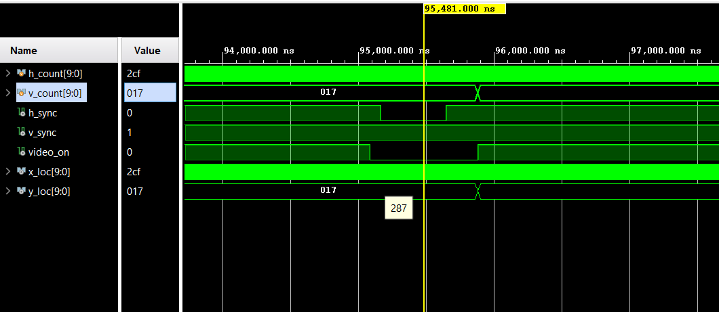
TEST CASE 4:-
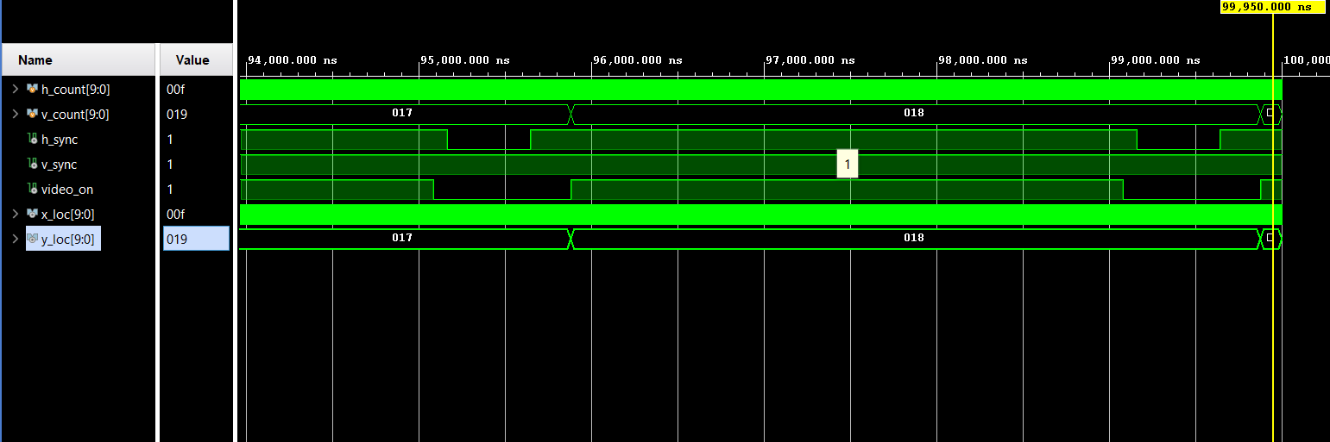

Comments
*Observation/Comments on the obtained results/working of code.
This module is designed to generate VGA synchronization signals (h_sync, v_sync) and identify the active video display region using video_on, x_loc, and y_loc. It uses input counters h_count and v_count which are typically driven by a VGA timing generator elsewhere in your system.

Task b: Pixel Generation

Code: Design pixel_gen
Provide appropriately commented code for designed module and the testbench, the, code should contain meaningful variable naming.
*Add snippet or Copy paste the code written in the Editor window. Make sure the irrelevant area of the snip is cropped.
CODE FOR DISPLAYING FLAG ON SCREEN:-

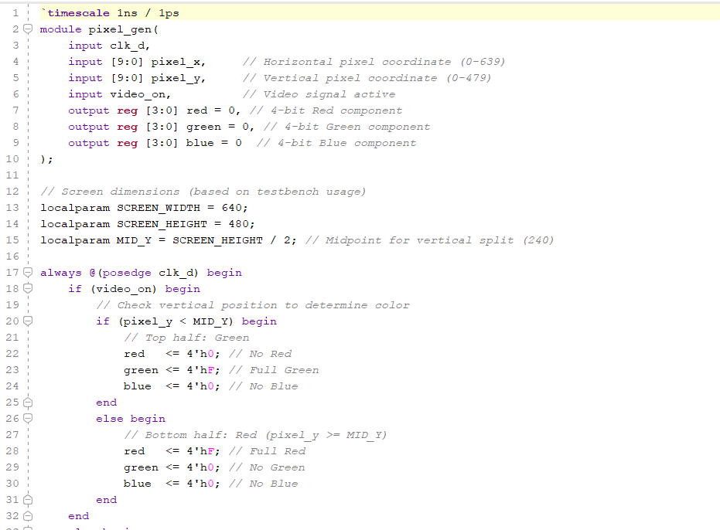

TEST BENCH:-
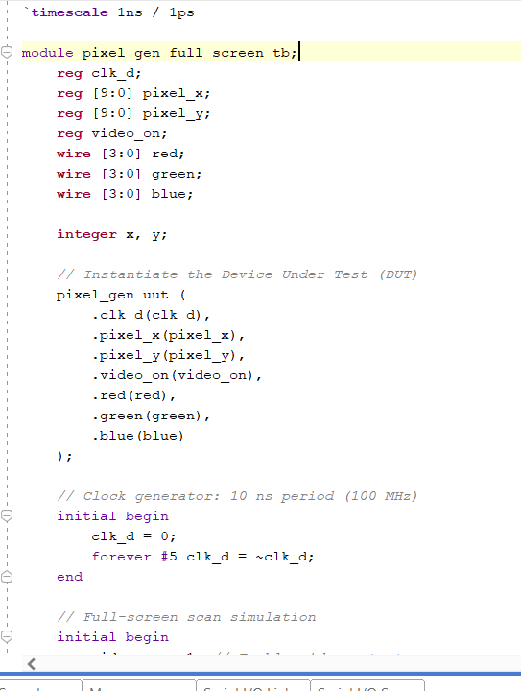

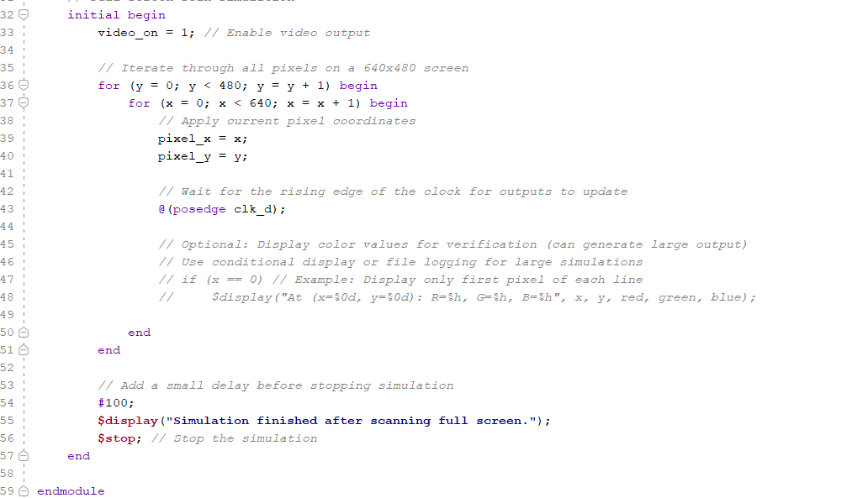

Results (Waveforms)
*Add snip of relevant signals’ waveforms. Make sure the irrelevant area of the snip is cropped.
make sure to scale properly for visibility of all case.

TESTCASE 1:-
• clk_d: This is the clock signal driving the module. You can see it oscillating between 0 and 1. pixel_x[9:0] and pixel_y[9:0]: These likely represent the x and y coordinates of the pixel being generated. You can observe them incrementing with each clock cycle. video_on: This signal is high (1), indicating that the video generation is active. red[3:0], green[3:0], blue[3:0]: These represent the color components of the pixel. In this snippet, they appear to be staying at 0, meaning the generated pixels are black. x[31:0] and y[31:0]: These might be internal counters or registers related to the pixel coordinates, also incrementing with the clock.
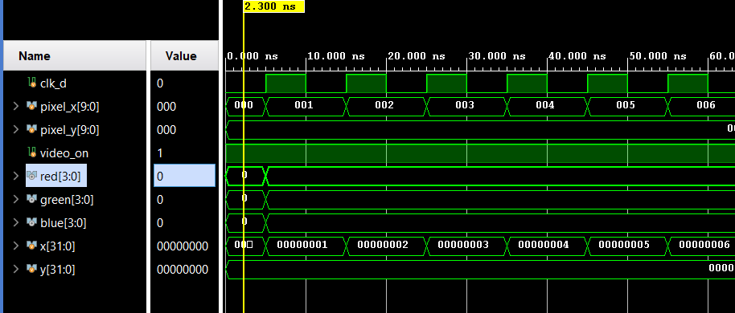

TESTCASE 2:-
• You can now see that at around 30 ns, the red[3:0] signal briefly becomes 000 (binary), while green[3:0] and blue[3:0] remain at f (likely representing their maximum value in hexadecimal, meaning full intensity if this is an RGB representation). Around 50 ns, all color signals (red[3:0], green[3:0], blue[3:0]) change to f. Notice that pixel_y[9:0] increments to 001 at approximately 60 ns, coinciding with pixel_x[9:0] resetting to 000. This suggests the module has completed a horizontal scan and is now moving to the next line. Correspondingly, y[31:0] also increments while x[31:0] resets
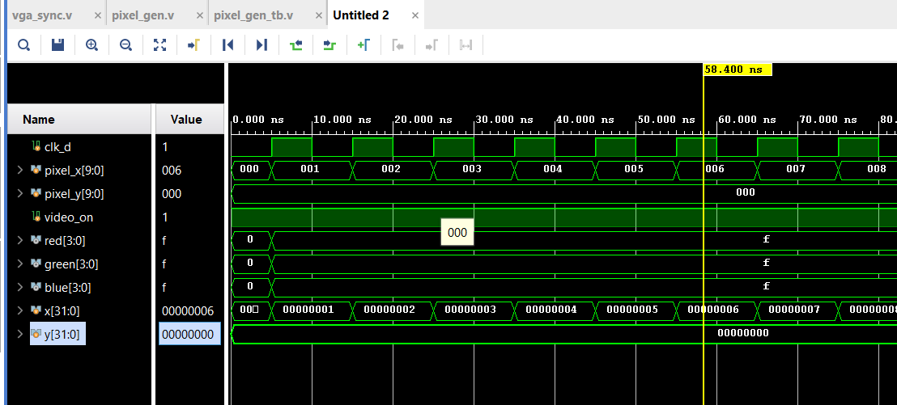

TESTCASE 3:-
The simulation is now focused around the 78,760 ns to 78,820 ns mark. pixel_x[9:0] continues to increment with each clock cycle, moving from 0c4 to 0cb. pixel_y[9:0] remains constant at 00c during this period, indicating that the module is still on the same horizontal line. video_on is still high, so pixel generation remains active.Notice a change in the red[3:0] signal. It transitions from f to 0 around 78,790 ns and then back to f shortly after 78,800 ns. The green[3:0] and blue[3:0] signals stay at f. This suggests a brief change in the red color component of the generated pixels. Correspondingly, x[31:0] continues to increment, and y[31:0] remains stable.
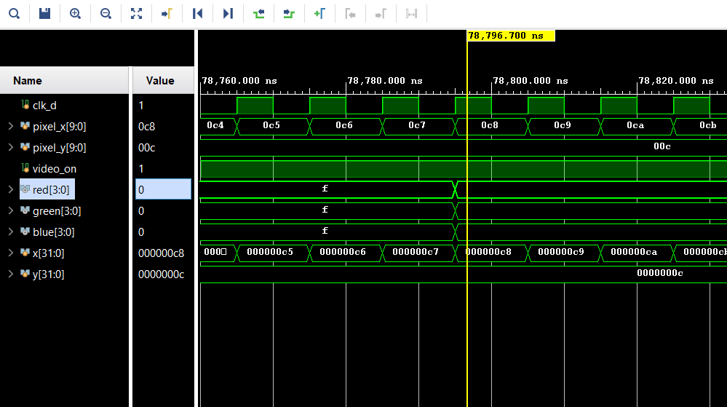

TESTCASE 4:-
The timeline now focuses around the 99,920 ns to 100,000 ns mark. pixel_x[9:0] continues its horizontal scan, incrementing from 187 to 190. Notice that pixel_y[9:0] has now incremented to 00f. This signifies that the module has moved to a new horizontal line after completing the previous one.
video_on remains high, keeping the pixel generation active. The color signals red[3:0], green[3:0], and blue[3:0] all stay at f, indicating that the generated pixels are currently white (assuming f represents the maximum intensity for each color component). Correspondingly, x[31:0] continues to increment, and y[31:0] now reflects the change in the vertical position, showing 0000000f.
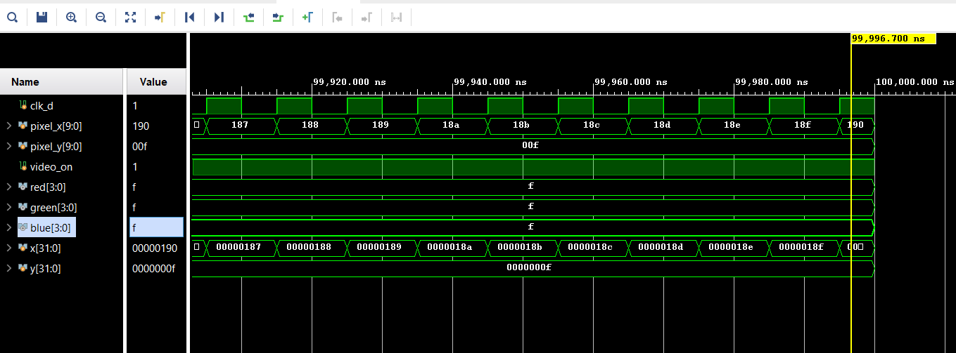

Task c: Top-Level Module/VGA Controller

Create a Top-Level Module as in Figure 11. 7. This module will receive a 100Mhz
Clock as input and generate 1-bit h_sync and v_sync signals and three 4-bit signals for
Red, Green and Blue color.

Code: Design module & testbench
Provide appropriately commented code for designed module & its testbench, code should contain meaningful variable names.
*Add snippet or Copy paste the code written in the Editor window. Make sure the irrelevant area of the snip is cropped.

SOURCE CODE:-

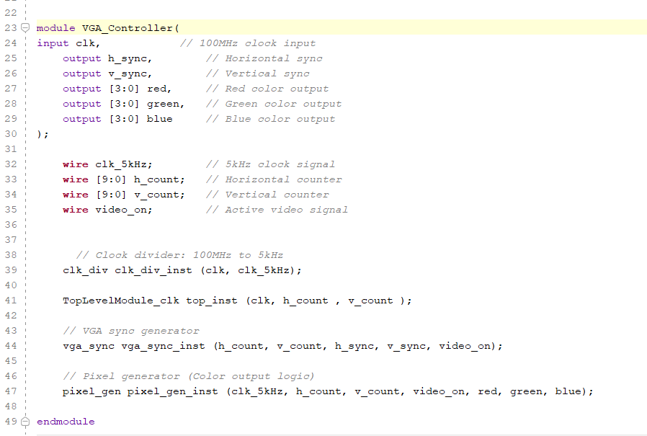

TESTBENCH:-
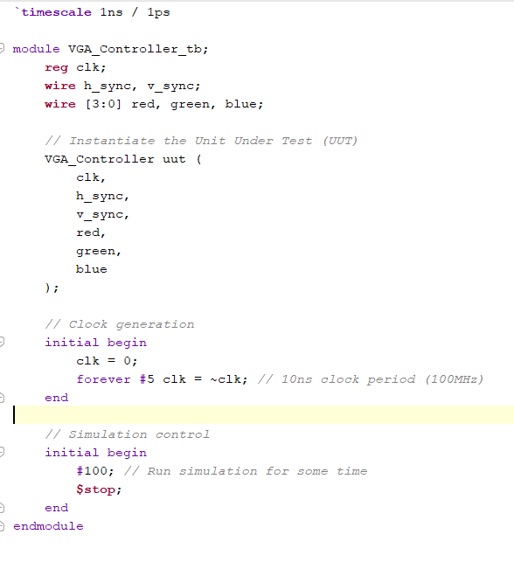

Constraint File

Copy & paste your constraint file (.xdc) here:
set_property PACKAGE_PIN J17 [get_ports {green[0]}]
set_property PACKAGE_PIN H17 [get_ports {green[1]}]
set_property PACKAGE_PIN G17 [get_ports {green[2]}]
set_property PACKAGE_PIN D17 [get_ports {green[3]}]
set_property IOSTANDARD LVCMOS33 [get_ports {green[*]}]

set_property PACKAGE_PIN N18 [get_ports {blue[0]}]
set_property PACKAGE_PIN L18 [get_ports {blue[1]}]
set_property PACKAGE_PIN K18 [get_ports {blue[2]}]
set_property PACKAGE_PIN J18 [get_ports {blue[3]}]
set_property IOSTANDARD LVCMOS33 [get_ports {blue[*]}]

set_property PACKAGE_PIN W5 [get_ports clk]
set_property IOSTANDARD LVCMOS33 [get_ports clk]

set_property PACKAGE_PIN P19 [get_ports h_sync]
set_property IOSTANDARD LVCMOS33 [get_ports h_sync]

set_property PACKAGE_PIN R19 [get_ports v_sync]
set_property IOSTANDARD LVCMOS33 [get_ports v_sync]

set_property PACKAGE_PIN G19 [get_ports {red[0]}]
set_property PACKAGE_PIN H19 [get_ports {red[1]}]
set_property PACKAGE_PIN J19 [get_ports {red[2]}]
set_property PACKAGE_PIN N19 [get_ports {red[3]}]
set_property IOSTANDARD LVCMOS33 [get_ports {red[*]}]

Results
Implement1 the VGA controller on BASYS-03 board and show output on VGA
monitor. The display output is shown in Figure 11. 8. The VGA port connections are
shown in Figure 11. 9.

Demonstrate your working VGA monitor to respective RA. Attach the picture of your output screen.
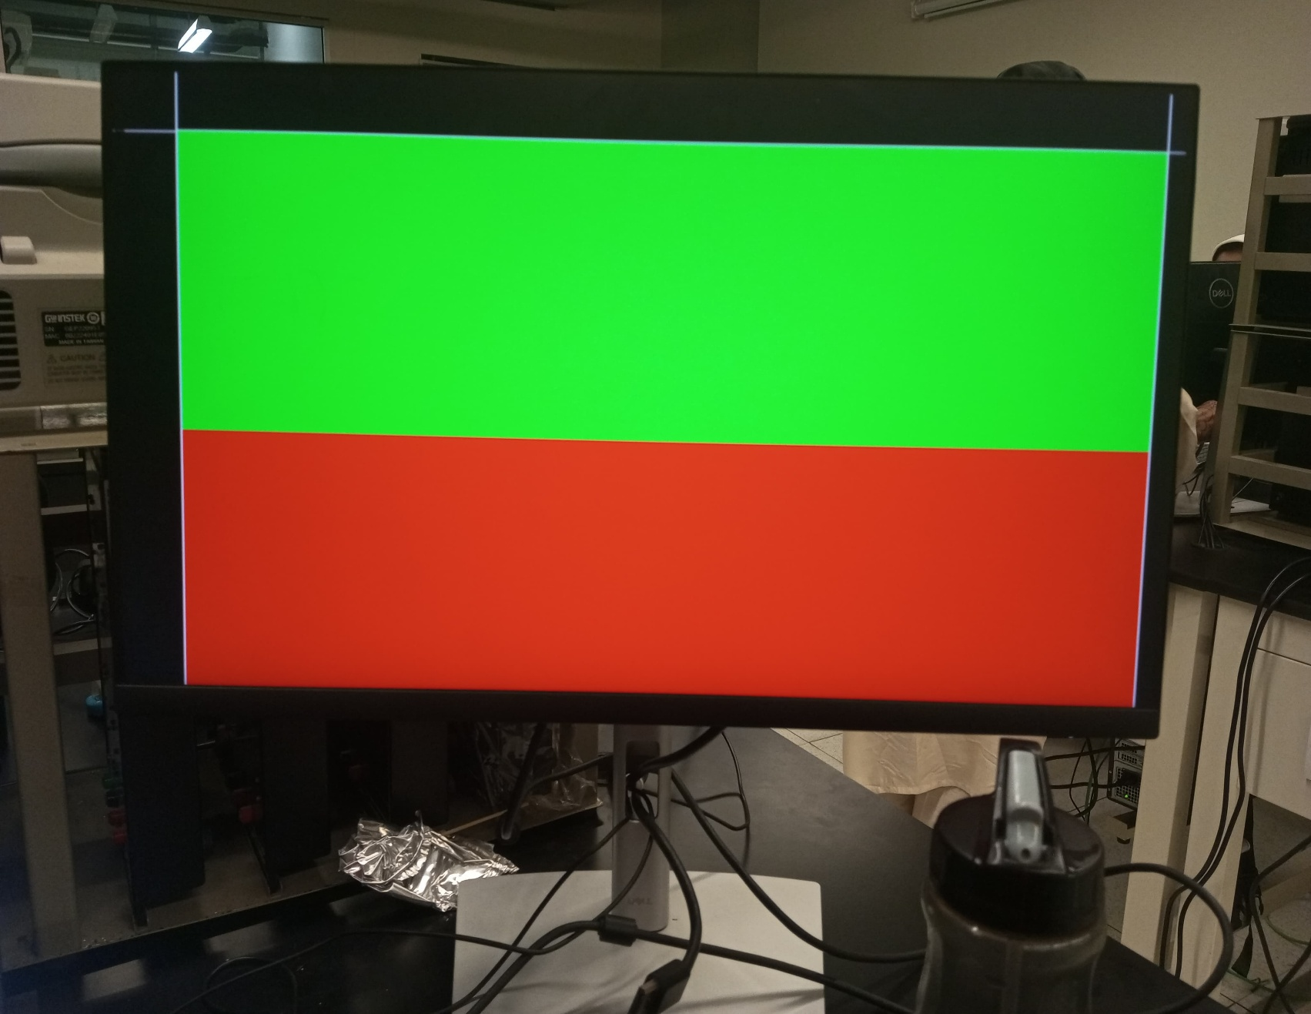

Comments
*Observation/Comments on the obtained results/working of code.
This code describes a VGA controller module. It takes a fast clock (100MHz), divides it to a slower clock (5kHz), and uses horizontal and vertical counters to generate VGA synchronization signals (h_sync, v_sync) and pixel color data (red, green, blue). The simulation shows the counters incrementing and the pixel color changing over time, indicating the module is scanning through pixels and generating a display signal.

Exercise
Code: Design module & testbench
Provide appropriately commented code for designed module & its testbench, code should contain meaningful variable naming.
*Add snippet or Copy paste the code written in the Editor window. Make sure the irrelevant area of the snip is cropped.

PIXEL GEN CODE FOR CHESS BOARD:-
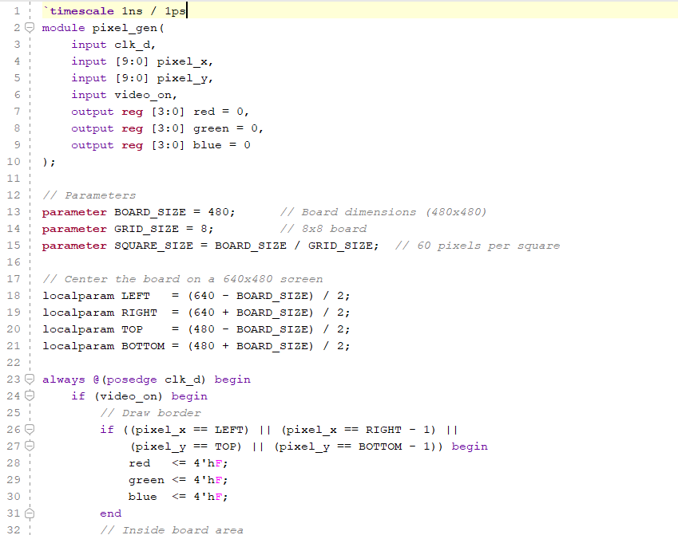

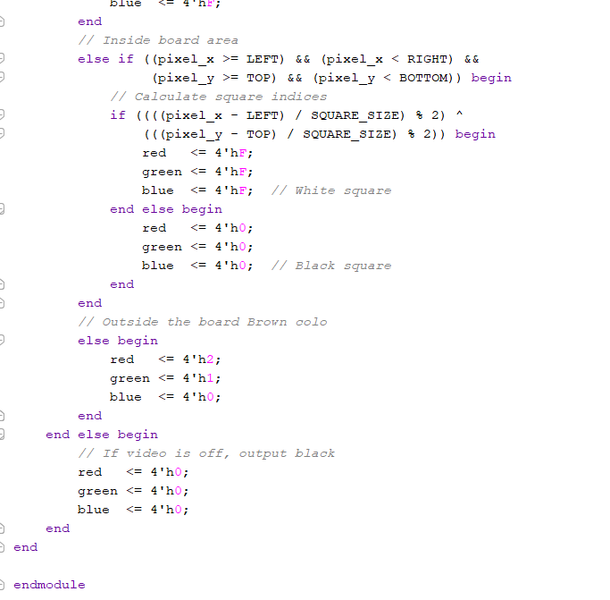

TESTBENCH:-
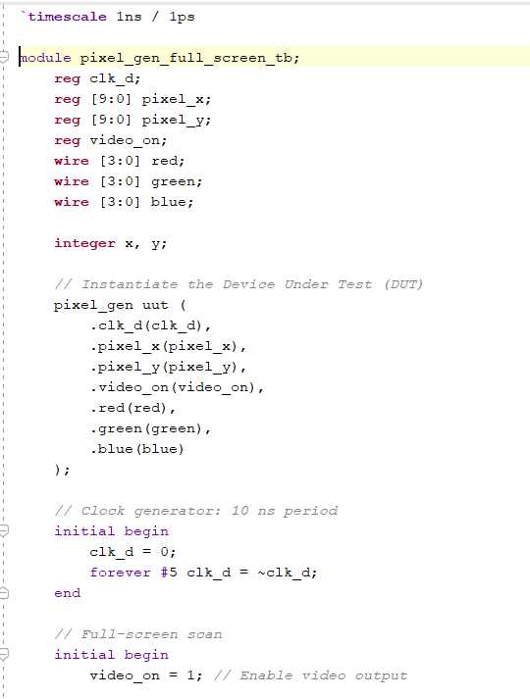
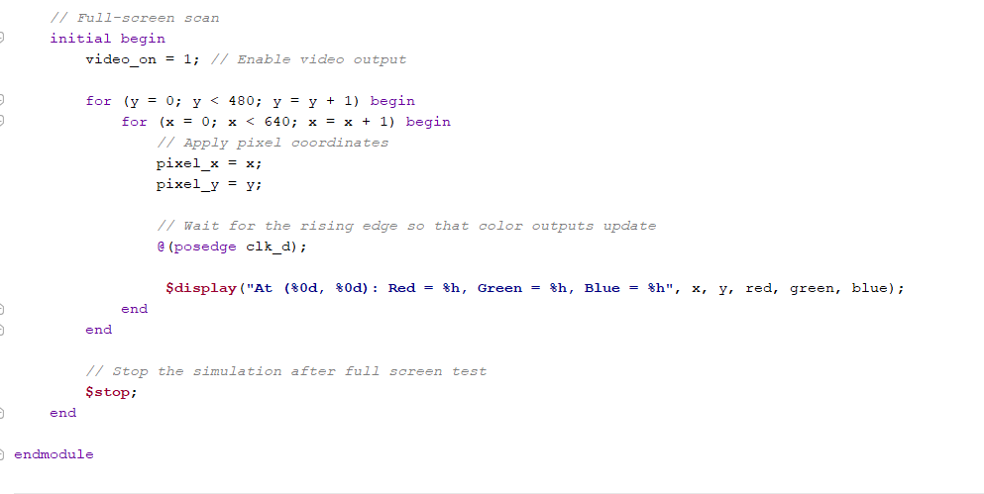

Results (Waveforms)
Attach a clear picture of the Monitor output here
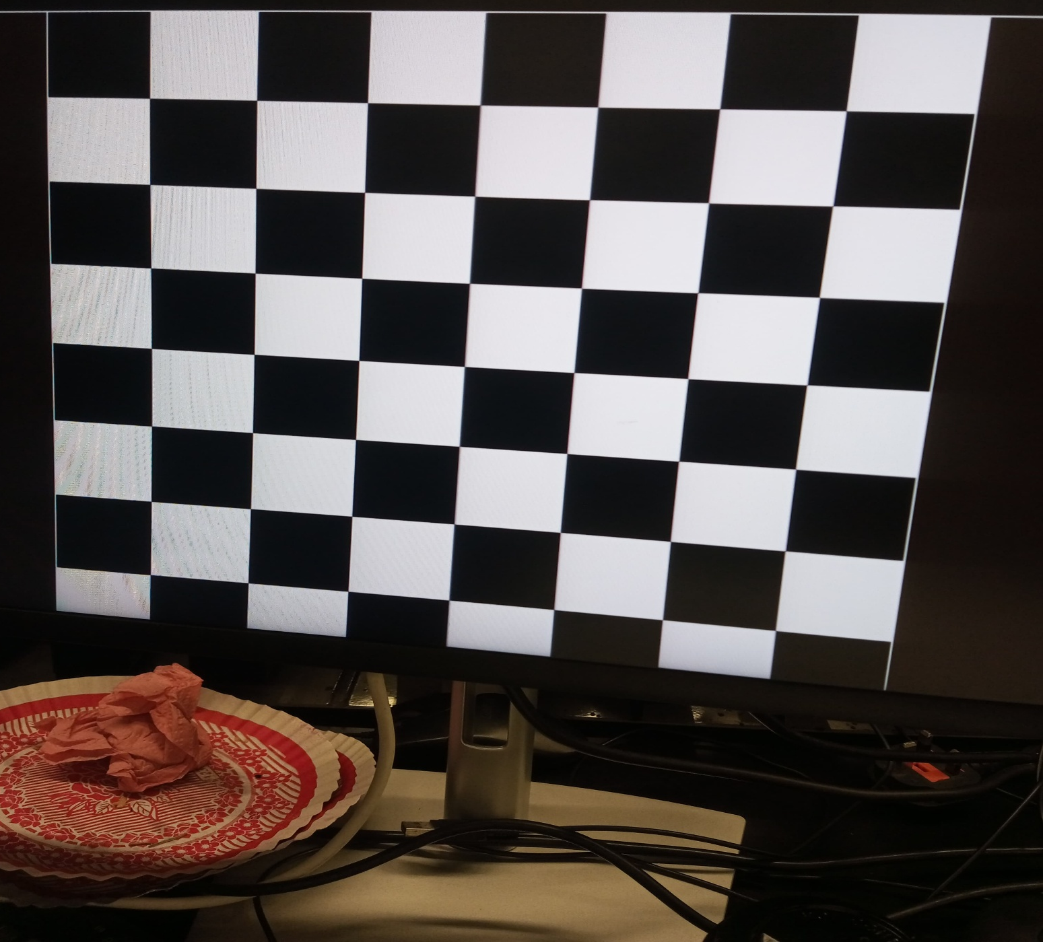

Comments
*Observation/Comments on the obtained results/working of code.
• Centering & Board Definition: It defines a 480x480 pixel area (BOARD_SIZE) centered on the screen using LEFT, RIGHT, TOP, BOTTOM coordinates. This board is divided into an 8x8 grid (GRID_SIZE), making each square 60x60 pixels (SQUARE_SIZE).
• Video On Check: The logic only generates colors when the video_on signal is high. Otherwise, it outputs black.
• Drawing Logic (when video is on): Border: If the pixel coordinates (pixel_x, pixel_y) match the exact edges of the centered board (LEFT, RIGHT-1, TOP, BOTTOM-1), it draws a white border. Checkerboard: If the pixel is inside the board area (but not the border), it calculates which square the pixel falls into. Using modulo arithmetic and XOR (^), it determines if the square should be black or white, creating an alternating checkerboard pattern.Outside Area: If the pixel is outside the defined board area, it outputs a brown color (R=2, G=1, B=0).

Assessment Rubric

Lab 11
VGA Controller

Student ID:
Name:

Marks Distribution:

 | Task No. | LR2  Code | LR5  Results
In - Lab | Task a | /20 | /05
In - Lab | Task b | - | -
In - Lab | Task c | /10 | /15
Exercise |  | /20 | /15
Total: 100 |  | /50 | /35
CLO Mapping |  | CLO3 | CLO3

Affective Domain Rubric |  | Points | CLO Mapped
AR 7 | Report Submission and Viva | /15 | CLO 4

CLO | Total Points | Points Obtained
3 | 85
4 | 15
Total | 100

For description of different levels of the mapped rubrics, please refer to the provided Lab Evaluation Assessment Rubrics and Affective Domain Assessment Rubrics.

Lab Evaluation Assessment Rubrics
# | Assessment Elements | Level 1: Unsatisfactory Points 0-1 | Level 2: Developing  Points 2 | Level 3: Good  Points 3 | Level 4: Exemplary  Points 4
LR1 | Circuit Layout | Connections between circuit components are mostly wrong. Circuit layout is cluttered.  Needs guidance to make correct equipment/ component connections. | Few of the connections made between circuit components are wrong. Circuit layout is not neat and clean as per standards. | Circuit layout and connections are correct but not all connections are neat and clean as per standards. | Neat, clean and correct connections of all the circuit components/ equipment are made as per standard circuit diagram.
LR3 | Troubleshooting | Unable to identify the fault/minimal effort shown in troubleshooting. | Able to identify the fault but unable to remove it. | Able to identify the fault but partially removes it. | Able to identify the fault and takes necessary steps and actions to correct it.
LR5 | Results & Plots | Figures/ graphs / tables are not developed or are poorly constructed with erroneous results. Titles, captions, units are not mentioned.  Data is presented in an obscure manner. | Figures, graphs and tables are drawn but contain errors. Titles, captions, units are not accurate. Data presentation is not too clear. | All figures, graphs, tables are correctly drawn but contain minor errors or some of the details are missing. | Figures / graphs / tables are correctly drawn and appropriate titles/captions and proper units are mentioned. Data presentation is systematic.
LR7 | Viva | Response shows a complete lack of understanding of the assigned / completed task | Response shows shallow understanding of the assigned task | Response shows substantial understanding of the assigned task | Response shows complete understanding of the completed task. The student is able to explain all the related concepts.
LR10 | Analysis | Results are not interpreted or are analyzed incorrectly. | Analysis of the obtained results is incomplete.  Conclusions are not drawn. | Results are analyzed and concluded but are not well explained and justification is not provided with the help of reasoning. | Results are well analyzed supported with reasons. Good comparison is made between the theoretical and experimental results with correct and useful conclusion.
LR11 | Design | Proposed design is unsubstantiated or does not satisfy most of given constraints. The breakdown of system into features is incomplete and still at lower resolution. | Justification for proposed design is weak, and it only satisfies some constraints. The breakdown of system is missing some features and resolution is not appropriate at some places. | Proposed design is substantiated, preferably through proper analysis, and satisfies most given constraints. The breakdown of system into features seems complete, but resolution is not appropriate at some places. | Proposed design is substantiated, preferably through proper analysis, and satisfies all given constraints. The breakdown of system into features seems complete and at appropriate resolution, given students' level.

